

Faculty of Computer Science & Information Computing Technology

Department of information Computing technology

Diploma in Computer Science

TNWK213

Netwoking

Danerson Teh Jie Sheng 2370276-DCS

Lai Jun Cheng 2370293-DCS

Wong Weng Hong 2390009-DCS

Tan Juin Wei 2390032-DCS

Lecturer: Rozlinda Radzali

Date of submission:

**CONTENT:**

1.0 INTRODUCTION

1.1 Background

1.2 Scope

2.0 FLOOR PLAN LAYOUT

2.1 Floor plan and lagend

2.2 Details of the layout & number of devices used

3.0 NETWORK DEVICES

3.1 Router

3.2 Switch

3.3 Cabling

4.0 NETWORK DESIGN

4.1 Side View of Network Diagram

4.2 Aerial View of Network Diagram

4.3 Network Design(Packet Tracer)

5.0 INDIVIDUAL COMPONENTS

6.0 CONCLUSION

7.0 REFERENCES

**1.0 INTRODUCTION**

A university has given our group the opportunity to develop a reliable network design and specifications for their new building. The main goal of this project is to establish a functional, advanced, and efficient computer network that meets the specific needs of corporate training. With the new building expected to accommodate many students and staff, our group plans to design a strong network infrastructure that can easily handle the growing demands for connectivity, communication, and data exchange.

**1.1 Background**

The objective of this network design project is to develop a comprehensive LAN that connects multiple buildings, ensuring every device within the network can communicate effectively and access the internet without interruption. The network will be designed to support the diverse needs of the organization, with a focus on scalability, reliability, and security.

The type of organization in focus for this network design is a university. This university comprises various structures, including lecturers’ offices, classrooms, laboratories, and canteens, each spanning multiple floors and buildings. The network will connect all buildings and floors within these structures, providing students, faculty, and administrative staff with uninterrupted internet access and network resources. By creating a detailed network plan, the goal is to enhance the school's educational and operational efficiency, supporting its mission to deliver high-quality education and services.

**1.2 Scope**

Our project involves the design, implementation, and evaluation of a Local Area Network (LAN). To achieve our ambitious goals, we are developing a comprehensive LAN architecture that connects multiple buildings within the new university complex, including lecturers' offices, classrooms, laboratories, and canteens, ensuring seamless connectivity across all floors and structures. Additionally, our group will ensure the network design provides reliable and uninterrupted internet access for all users, including students, faculty, and administrative staff, to support educational and operational activities. Moreover, we guarantee that all devices within the network will communicate effectively and access network resources without interruption.

To allow for easy expansion and integration of additional buildings, devices, and users as the university grows, we are designing the network with future growth in mind. Furthermore, by implementing robust infrastructure and redundancy measures, we are minimizing downtime and ensuring continuous network availability. Lastly, we are incorporating advanced security protocols to protect sensitive data and prevent unauthorized access, ensuring the privacy and integrity of the university's network resources.

**2.0 Floor Plan Layout**

**2.1 Floor plan and Legend**

**Classroom**

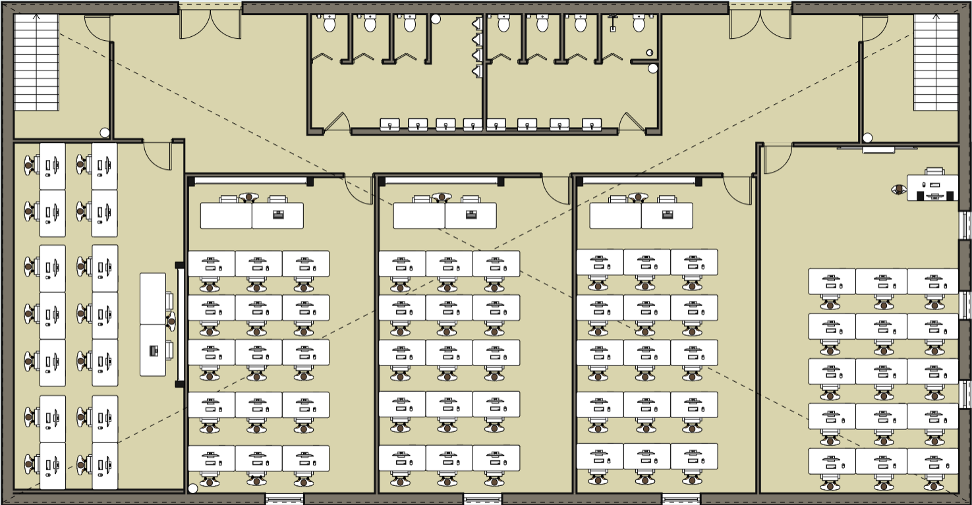

**Laboratory**

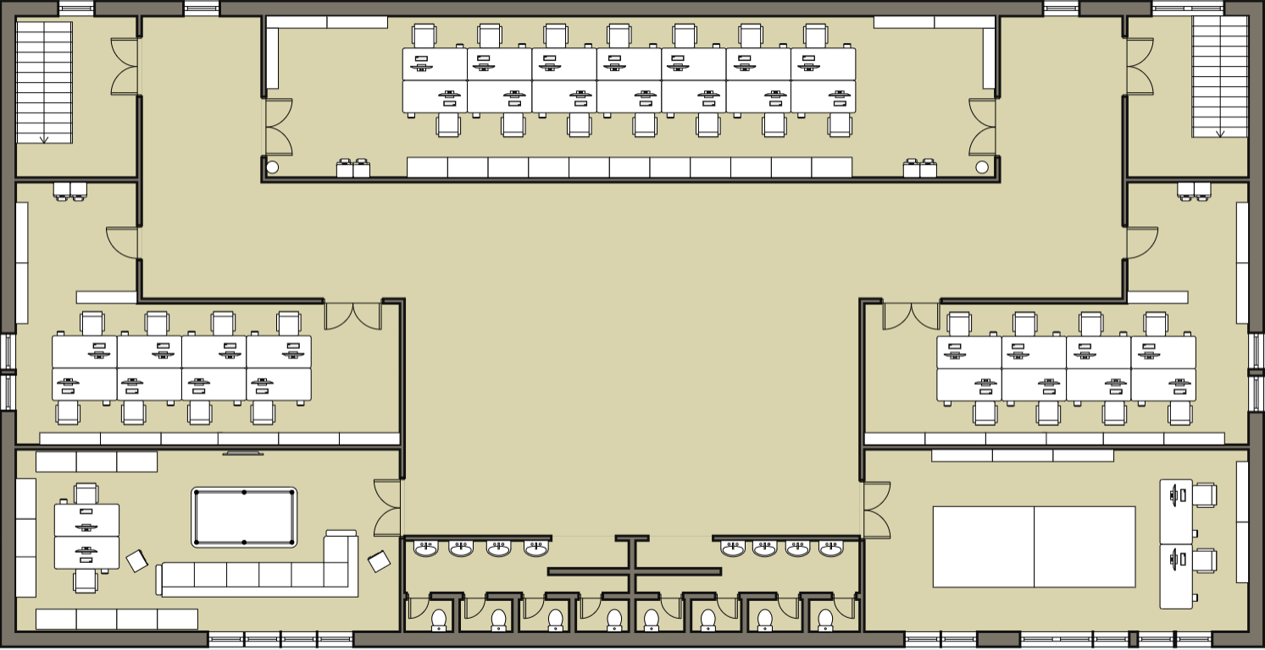

**Canteen**

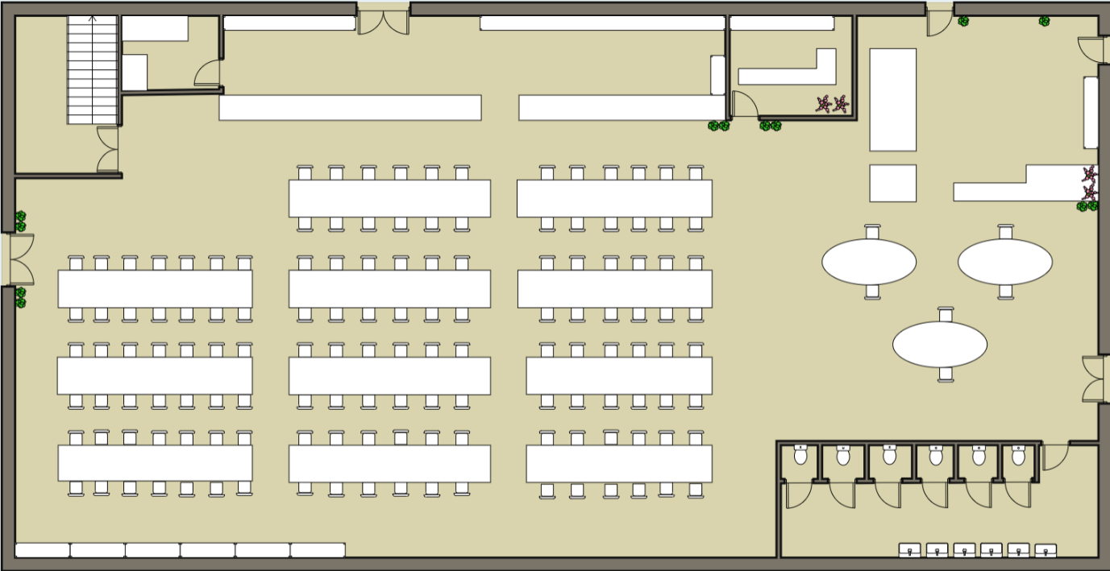

**Office**

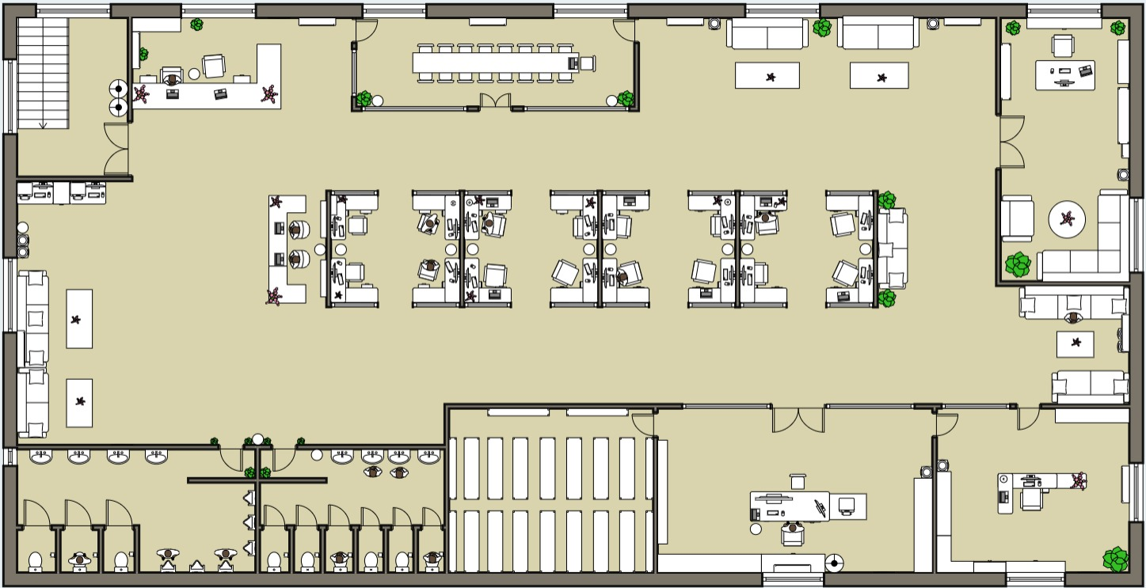

**Lagend:**

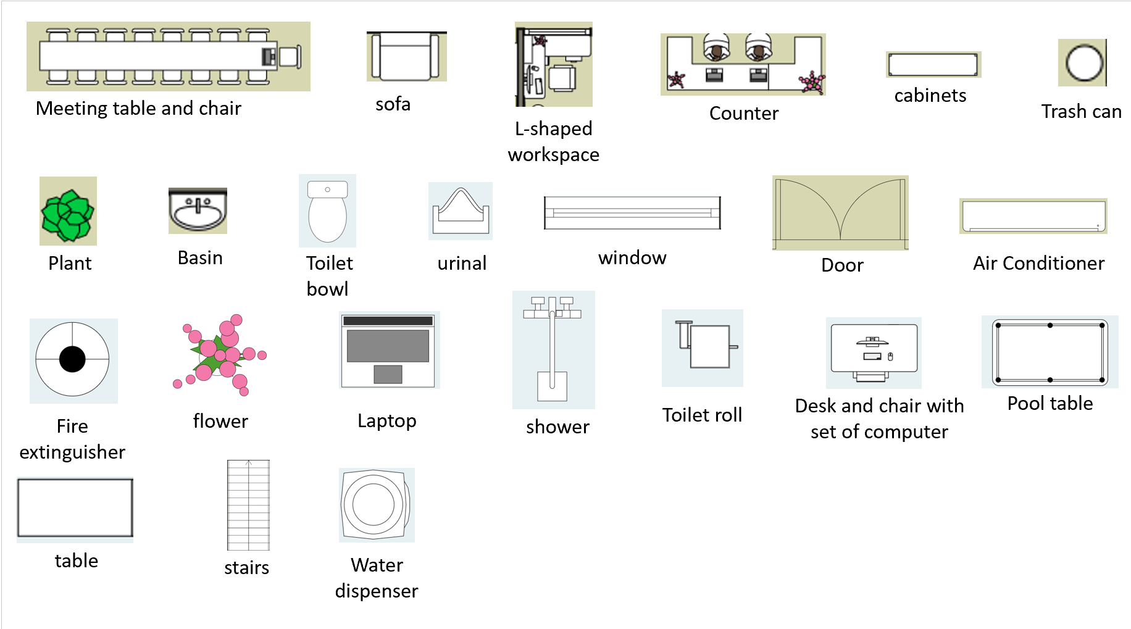

**2.2 Justification of Floor Plan Design**

This floor plan design comprises of two building which is an office building and a training building, each consist of two floors. Enough to allocate all facilities needed for a university, which are classroom, laboratory, canteen, and office.

Justification for building 1 floor plan first floor, which is a classroom. The allocation of the classroom at the first floor is well-founded. Classroom as the fundamental facilities for all educational institution, placing it as the first floor make student able to access it easily, because student all going to access it routinely, it will be a huge trouble if student needed to walk more to reach it. The first-floor classroom also has a suitable length of corridor in the central so that the student doesn't need to take a long way to reach their learning space, this design is user-friendly and reducing the need of movement within the building to reach the classroom.

The allocation of the second floor of building 1 to a laboratory is a strategic decision. All the expensive and specialize equipment are usually placing on laboratory, and it should not be placing near easy access places to minimize the risk that other miscellaneous could accidentally broke one or two equipment that are place in the laboratory. In addition, placing the laboratory on the second floor also have its own safety consideration. Placing it on the second floor avoid easy access from outside to ensure that hazardous materials or sensitive information does not harming or knowing by miscellaneous people. Moreover, placing it on the second floor offers better natural ventilation and air quality, this could help maintaining a cleaner atmosphere or in the effective dispersion of any potential contaminants.

Justification for building 2 floor plan first floor. Placing a canteen on a first floor is a logical choice, this provides accessibility to everyone in the building. The first floor often acts as a central hub of a building, where people naturally pass through, placing canteen on the first floor not only reduce the need of students, employees, and visitors to travel far away from the building to easily access it, also helping to manage foot traffic better, ensuring people can easily stop by for their meal without disrupting the flow of movement. The first floor typically has better access to utilities such as water, gas, and electricity, which are essential for the operation of a canteen. This can make installation and maintenance of kitchen equipment easier and more cost-effective.

The allocation of the second floor of building 2 to office and server room is a practical choice, this could separate it from the public area, which is the first-floor canteen. The reason is because the second floor is generally more private and secure than the ground floor, this separation helps maintaining a secure and quite environment in both office works and server operations.

Having the server room close to the office allows administrator and other IT stuff to easily access the server for regular maintenance, troubleshooting, and monitoring. Apart from that, by placing the server room near the office, administrator can better control access to the servers, as office areas often have restricted entry and are monitored. This reduces the downtime and the risk of unauthorize access to critical infrastructure.

**3.0 Network Devices**

**3.1 Router**

|  |  |  |
| --- | --- | --- |
| Device name | TL-ER6020 | FS S3260-16T4P |
| Ports | 10/100/1000 Base-T RJ45 x5 | 10/100/1000 Base-T RJ45 x16  1G RJ45/SFP Combo x2  1G SFP x2 |
| Rack width | 1U | 1U |
| Wired/wireless | Wired | Wired |
| Lan switching port | 3 | 18 |
| price | RM699 | RM1663 |
| Picture of product |  |  |

The TL-ER6020 offers 5 Gigabit RJ45 ports and 3 LAN switching ports for RM699. In contrast, the FS S3260-16T4P provides 16 Gigabit RJ45 ports, 2 RJ45/SFP Combo ports, and 2 SFP ports, resulting in 18 LAN switching ports, priced at RM1663. After comparing both 2 routers, despite the higher cost, the FS S3260-16T4P is the best choice due to its significantly greater port capacity and flexibility, making it ideal for larger and more complex network setups.

**3.2 switch**

|  |  |  |
| --- | --- | --- |
| Device Name | FS S3400-24T4FP | FS S3900-48T6S-R |
| Forwarding rate | 42Mpps | 162Mpps |
| Switching capacity | 56Gbps | 216Gbps |
| Port quantity | 24 | 48 |
| Wireless/wired | Wired | Wired |
| Price | RM2033 | RM2126 |
| Rack width | 1U | 1U |
| Picture of product |  |  |

Comparing the FS S3400-24T4FP and the FS S3900-48T6S-R reveals the superiority of the FS S3900-48T6S-R. The FS S3400-24T4FP has a forwarding rate of 42Mpps, a switching capacity of 56Gbps, and 24 ports, priced at RM2033. In contrast, the FS S3900-48T6S-R boasts a forwarding rate of 162Mpps, a switching capacity of 216Gbps, and 48 ports, priced at RM2126. Both are 1U, wired switches. Despite the slightly higher price, the FS S3900-48T6S-R is the better choice due to its higher performance and greater port capacity, making it ideal for demanding network environments.

**3.3 cabling**

|  |  |  |
| --- | --- | --- |
| Cable type | CAT5e | CAT6 |
| Max bandwidth | 100MHz | 250MHz |
| Max data rate | 1Gbps | 1Gbps |
| Connector | RJ45 | RJ45 |
| shielding | UTP/STP | UTP/STP |
| cost | Varies by length and manufacturer, usually RM10-RM13 per meter | Varies by length and manufacturer, usually  RM12-RM16 per meter |
| Image of product |  |  |

After comparing both cables, CAT6 cables are choosed over CAT5e for higher performance, offering a maximum bandwidth of 250MHz compared to CAT5e's 100MHz, while both support a data rate of 1Gbps. CAT6 cables come with the same RJ45 connectors and can be shielded with UTP or STP, similar to CAT5e. Although CAT6 cables tend to be more expensive, ranging from RM12 to RM16 per meter compared to CAT5e's RM10 to RM13 per meter, the improved bandwidth makes CAT6 a better choice for future-proofing and handling more demanding network applications.

**4.0 Network Design**

**4.1 Side view of Network Diagram**

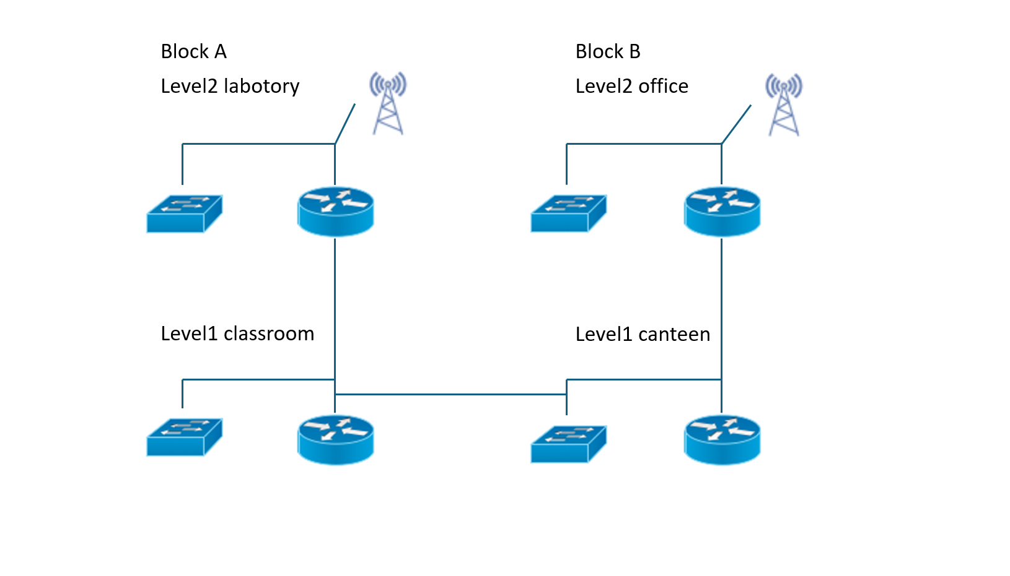

**4.2 Aerial View of Network Diagram**

Classroom

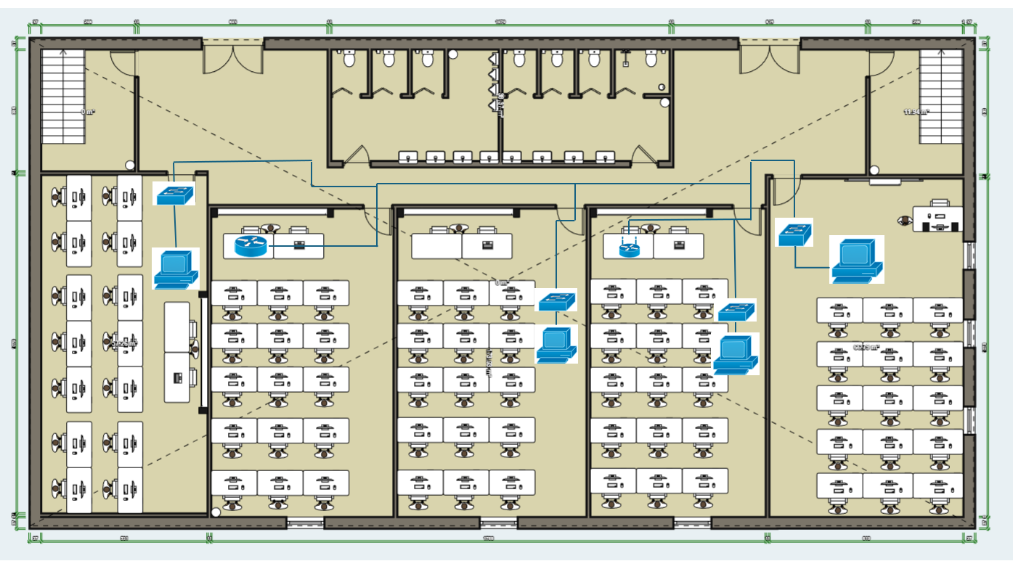

Laboratory

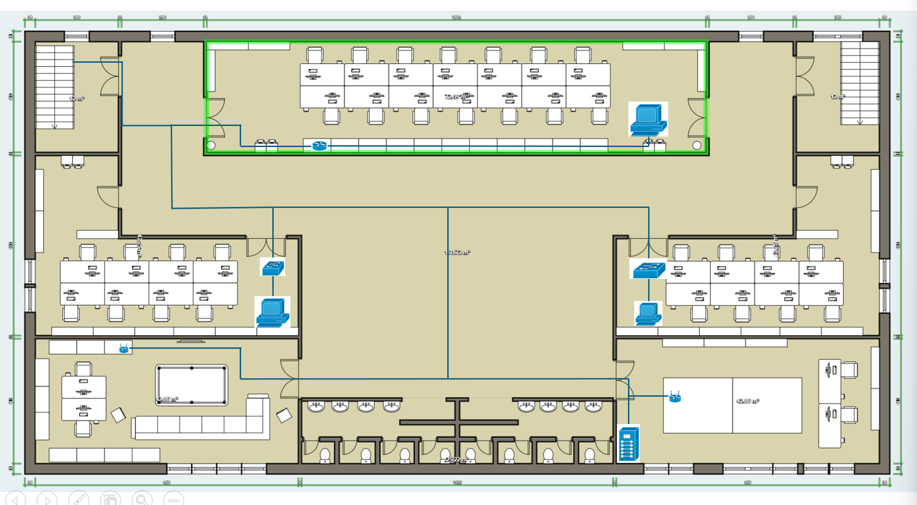

Canteen

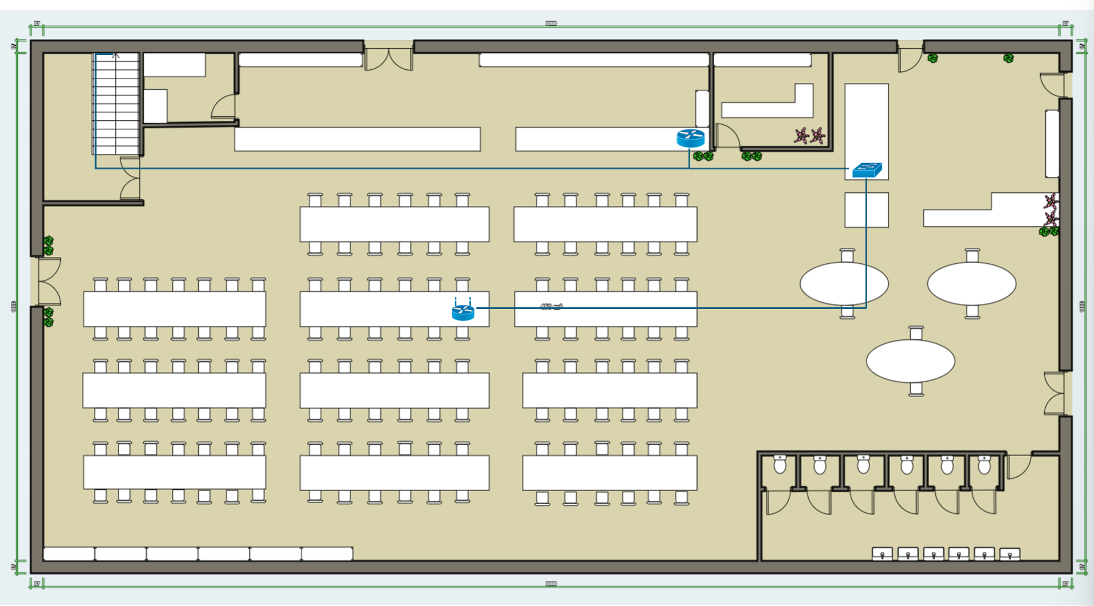

Office

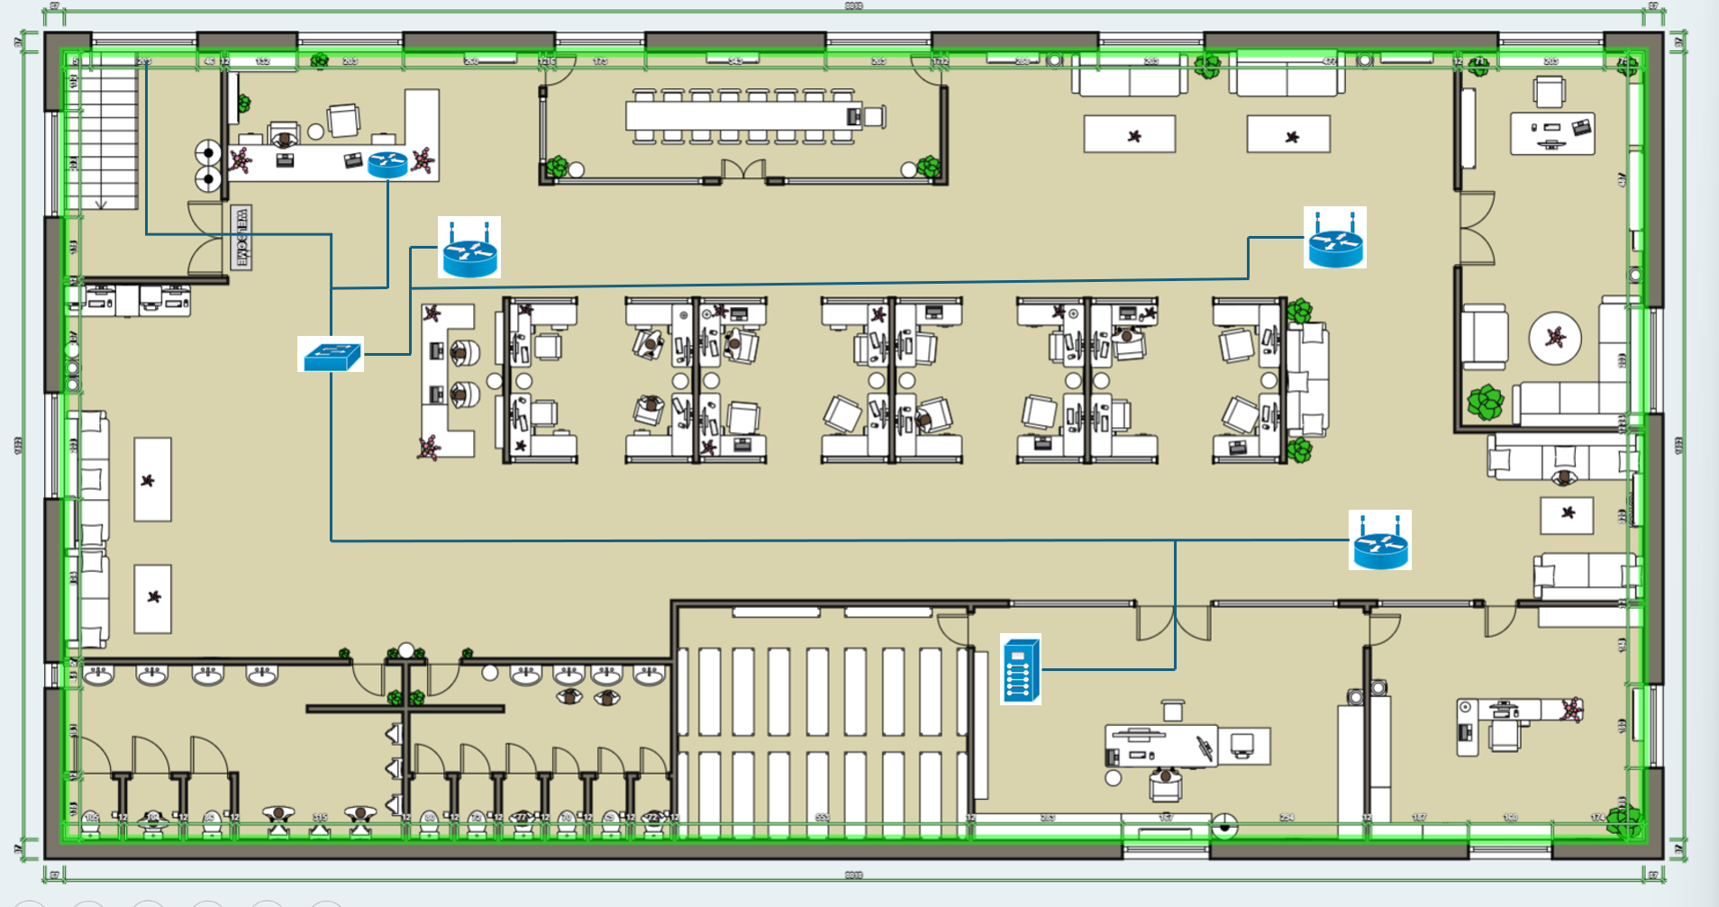

Lagend

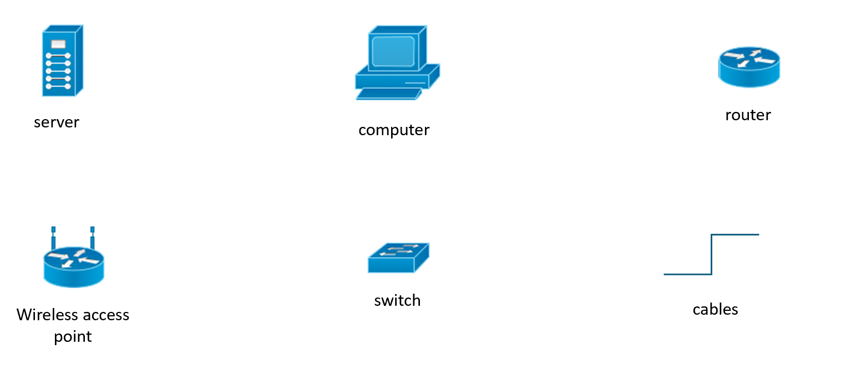

**4.3 Network Design(packet tracer)**

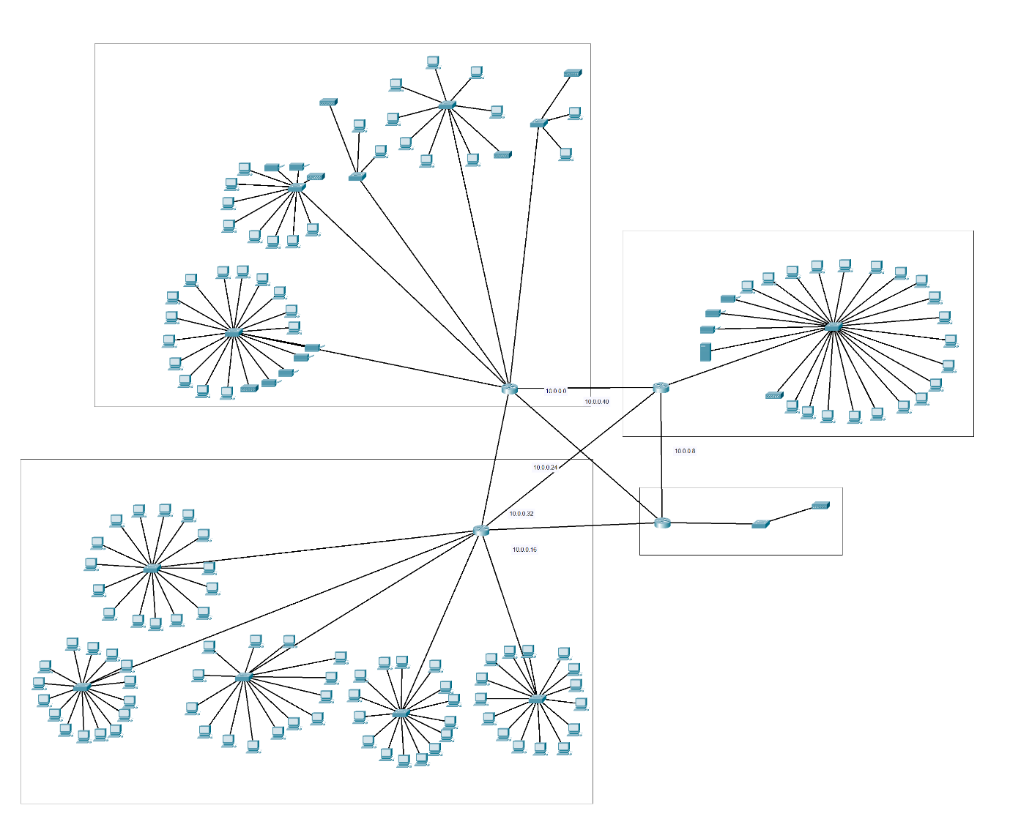

**5.0 Individual component**

**5.1 Ip configuration(Tan Juin Wei)**

IP address assign

|  |  |  |  |  |
| --- | --- | --- | --- | --- |
| Routers | Interfaces | Network Address | IP Address | Subnet mask |
|  | FE0/1 | 10.0.0.40 | 10.0.0.41 | 255.255.255.248 |
| Router0 | FE0/2 | 10.0.0.0 | 10.0.0.1 | 255.255.255.248 |
|  | FE0/3 | 10.0.0.24 | 10.0.0.25 | 255.255.255.248 |
|  | FE0/1 | 10.0.0.16 | 10.0.0.17 | 255.255.255.248 |
| Router1 | FE0/2 | 10.0.0.32 | 10.0.0.34 | 255.255.255.248 |
|  | FE0/3 | 10.0.0.24 | 10.0.0.26 | 255.255.255.248 |
|  | FE0/1 | 10.0.0.8 | 10.0.0.9 | 255.255.255.248 |
| Router2 | FE0/2 | 10.0.0.0 | 10.0.0.2 | 255.255.255.248 |
|  | FE0/3 | 10.0.0.32 | 10.0.0.33 | 255.255.255.248 |
|  | FE0/1 | 10.0.0.40 | 10.0.0.42 | 255.255.255.248 |
| Router3 | FE0/2 | 10.0.0.8 | 10.0.0.10 | 255.255.255.248 |
|  | FE0/3 | 10.0.0.16 | 10.0.0.18 | 255.255.255.248 |

IP address: 172.16.0.0

Subnet to subnet mask 255.255.240.0

172.16.0.0/20

Router0(Router for first block laboratory)

There is 5 switches

|  |  |  |  |  |  |  |
| --- | --- | --- | --- | --- | --- | --- |
| Switches | End Devices | Interfaces | Network address | IP address | Default Gateway | Subnet mask |
|  | PC0-13 | FE0/2-15 | 172.16.80.0 | 172.16.80.2-15 | 172.16.80.1 |  |
| Switch0 | Wireless Access Point | FE0/16 | N/A | N/A | N/A |  |
|  | Printer0-3 | FE0/17-20 | 172.16.80.0 | 172.16.80.16-19 | 172.16.80.1 |  |
|  | PC14-21 | FE0/2-9 | 172.16.96.0 | 172.16.96.2-9 | 172.16.96.1 |  |
| Switch1 | Printer4-5 | FE0/10-11 | 172.16.96.0 | 172.16.96.10-11 | 172.16.96.1 |  |
|  | Wireless Access Point | FE0/12 | N/A | N/A | N/A |  |
|  | PC22-23 | FE0/2-3 | 172.16.112.0 | 172.16.112.2 | 172.16.112.1 |  |
| Switch2 | Wireless Access Point | FE0/4 | N/A | N/A | N/A |  |
| Switch3 | PC24-31 | FE0/2-9 | 172.16.128.0 | 172.16.128.2-9 | 172.16.128.1 | 255.255.240.0 |
|  | Wireless Access Point | FE0/10 | N/A | N/A | N/A |  |
|  | PC32-33 | FE0/2-3 | 172.16.144.0 | 172.16.144.2-3 | 172.15.144.1 |  |
| Switch4 | Wireless Access Point | FE0/4 | N/A | N/A | N/A |  |

Router1(Router for first block classroom)

There is 5 switches

|  |  |  |  |  |  |  |
| --- | --- | --- | --- | --- | --- | --- |
| Switches | End Devices | Interfaces | Network Address | IP address | Default Gateway | Subnet mask |
| Switch5 | PC34-48 | FE0/2-15 | 172.16.0.0 | 172.16.0.2-15 | 172.16.0.1 |  |
| Switch6 | PC49-64 | FE0/2-16 | 172.16.16.0 | 172.16.16.2-16 | 172.16.16.1 |  |
| Switch7 | PC65-80 | FE0/2-16 | 172.16.32.0 | 172.16.32.2-16 | 172.16.32.1 | 255.255.240.0 |
| Switch8 | PC81-96 | FE0/2-16 | 172.16.48.0 | 172.16.48.2-16 | 172.16.48.1 |  |
| Switch9 | PC97-115 | FE0/2-16 | 172.16.64.0 | 172.16.64.2-16 | 172.16.64.1 |  |

Router2(Router for second block office)

There is 1 switch

|  |  |  |  |  |  |  |
| --- | --- | --- | --- | --- | --- | --- |
| Switches | End Devices | Interfaces | Network Address | IP address | Default Gateway | Subnet mask |
| Switch10 | PC116-136 | FE0/2-21 | 172.16.160.0 | 172.16.160.2-21 | 172.16.160.1 |  |
|  | Printer6-8 | FE0/22-24 | 172.16.160.0 | 172.16.160.22-24 | 172.16.160.1 | 255.255.240.0 |
|  | DHCP Server | FE0/25 | 172.16.160.0 | 172.16.160.25 | 172.16.160.1 |  |
|  | Wireless Access Point | FE0/26 | N/A | N/A | N/A |  |

Router3(Router for second block canteen)

There is 1 switch

|  |  |  |  |  |  |  |
| --- | --- | --- | --- | --- | --- | --- |
| Switch | End Devices | Interfaces | Network Address | IP address | Default Gateway | Subnet mask |
| Switch11 | Wireless Access Point | FE0/2 | N/A | N/A | N/A |  |

DHCP server configuration

|  |  |  |  |  |  |
| --- | --- | --- | --- | --- | --- |
| IP Address | Subnet mask | Network Address | Default Gateway | DNS Server | Startup IP |
| 172.16.176.2 | 255.255.240.0 | 172.16.176.0 | 172.16.176.1 | 172.16.176.1 | 172.16.176.3 |

**5.1.1**

PACKET TRACER

**5.2 Wong Weng Hong**

Side view of Network Diagram

Aerial View of Network Diagram

Canteen floor plan

**5.3 Lai Jun Cheng**

Introduction, Background, Scope, floor plan layout

**5.4 Danerson Teh Jie Sheng**

Network Devices

**5.5 The part we all do together**

INTRODUCTION

Floor Plan Layout

**Reference:**

<https://www.tp-link.com/my/business-networking/vpn-router/tl-er6020/#overview>

<https://www.ipohonline.biz/brand-tplink/rou-tl-er6020>

<https://www.fs.com/sg/products/103011.html?country=my&currency=MYR&languages=English&paid=google_shopping&utm_country=9198371&gad_source=1&gclid=Cj0KCQjwtsy1BhD7ARIsAHOi4xaee3Nl6yIzLC3hmv4kaYAOZUNHMUp96__3evZlVIaN6hE4XhO3rQ4aAvTnEALw_wcB>

<https://www.fs.com/sg/products/90131.html?country=my&currency=MYR&languages=English&paid=google_shopping&utm_country=9198371&gad_source=1&gclid=Cj0KCQjwtsy1BhD7ARIsAHOi4xbbAuOmtVPNe-58ZkH-utqQ2KGhrzYWI6MyYhaVvIe0cq_uInwyyc0aAgGwEALw_wcB>

<https://www.fs.com/sg/products/134657.html?country=my&currency=MYR&languages=English&paid=google_shopping&utm_country=9198371&gad_source=1&gclid=Cj0KCQjwtsy1BhD7ARIsAHOi4xayXZmDhyavBW3mJmlwaogr0NLp4HhOs2VsYt6o27H0dfzrIAxjyfYaAuXtEALw_wcB>